**IHE Work Item Proposal**

**1. Proposed Work Item: Developing Interoperable Systems to Achieve Bed Management Functionality for Emergency Department Admissions**

Proposal Editor: Kevin Parker

Work Item Editor: Leslie DeYoung, David Gelman, Paul Rosenau

Date: September 3, 2015

Version: 1.1

Domain: ADT

**2. The Clinical Problem**

Access to robust bed management functionality is a significant need within healthcare systems. Beds are a scarce resource, and the limitation of access to beds leads to delays and waste within healthcare systems. Bed management is the ability for a healthcare facility or system to have real-time operational awareness of the status of all of its available beds and to be able to plan for the expedient use of this scarce resource through coordination of the bed turnover process. This includes not only scheduled (surgical) or unscheduled (direct or emergency department (ED)) admissions but also intra-facility and inter-facility transfers from within or from outside the healthcare system.

The maturity of the bed management system in use varies from hospital to hospital – from limited real-time awareness by a central bed authority (bed czar) to a robust, integrated health IT product which aids predictive planning and communication between various teams, and optimizes the availability of beds. Bed management IT products can be commercial off-the-shelf (COTS) products or home-grown. They can be separate IT packages or integrate functionality within an all-in-one health IT solution. While the solutions vary in terms of scale and degree of integration, the following set of functional components (although incorporated into different IT products in each site) is common to most systems:

* The electronic health record (EHR) which practitioners use to place orders and track care of patients
* The admit, discharge and transfer system (ADT) which stores data on visits and admissions and is the system of record for length of stay for billing purposes
* The bed management system (BMS) which provides real-time awareness of the status of beds (clean, dirty, occupied, reserved, etc.)
* The emergency department information system (EDIS) which tracks patient status and flow through the ED. If the ED has a standalone EHR which performs both care management and tracking, we consider this system as having both ED EHR and EDIS functionalities.

As an example, an estimated 420,000 patients are admitted per year from Veterans Health Administration (VHA) EDs; they represent 17% of the nearly 2.4 million ED visits1. The VHA has developed standalone home-grown applications to monitor patient flow and uses the following generic terms to identify these systems: EDIS (Emergency Department Integration Software) and BMS (Bed Management System). EDIS and BMS operate alongside CPRS/VistA, the VHA’s EHR (which includes an ADT system). However these three nationally-sanctioned IT products do not share data among themselves.

The current lack of interoperability between EDIS, BMS and CPRS creates several interrelated problems:

* Work inefficiency for ED providers and other staff who must enter or relay the same information to multiple actors (information systems and other staff) with no mechanism to monitor patient status in real time
* Delays in patient transfers to inpatient units associated with patient transfer messaging failures and rework
* Poor data quality with which to measure the performance of patient transfer and care coordination systems due to siloed data

**The goal of the proposed profile is to document the data exchange between interoperable systems that would enable bed management for patients admitted from the emergency department.**

**3. Value Statement**

Delays have financial and clinical costs. In a 2011 study, Pines et al. found that a one hour decrease in ED boarding times resulted in approximately $10,000 per day of increased revenue at their inner-city teaching hospital.2 It is probable that financial benefits would also be achieved in a VA hospital setting if post-admission delays were decreased in a manner similar to the one highlighted in this study. In addition, prolonged post-admission delays are associated with increased mortality and length of stay in the hospital, even controlling for acuity and comorbid conditions.3

**4. Use Case**

**Storyboard 1**

Mrs. Penny arrives for care in the ED where an administrative clerk creates an outpatient visit (registers) Mrs. Penny in the ADT system for the ED, which is part of the EHR system. This populates EDIS with Mrs. Penny’s name and visit information. Mrs. Penny is seen by Nurse Nickel, the triage nurse. Mrs. Penny receives care in the ED from Dr. Dent, who records himself as the provider of record in EDIS. During early care of Mrs. Penny, a nurse or doctor identifies that Mrs. Penny’s complaint is likely to result in an inpatient admission. Dr. Dent or Nurse Nickel can create a “heads up” notification in EDIS to communicate the potential of an admission for Mrs. Penny to BMS. This is not a formal admission order because the patient may not be fully stabilized for admission and the clinician may not know at this time all the information necessary for an admission order (for example: service, team, level of care, and isolation or cohabitation needs). The action of creating a “heads up” notification updates a list of patients in BMS to give operational awareness of an estimate of total pending admissions from the ED.

Care proceeds, and eventually Dr. Dent decides to admit Mrs. Penny to the hospital. At this time, he enters the details of the admission into EDIS, including the necessary information regarding her bed requirements (for example: service, team, level of care, and isolation or cohabitation needs). Cohabitation and/or Isolation needs are determined using clinical decision support accomplished via patient information retrieved from Mrs. Penny’s EHR; for instance, recommending isolation if data in the EHR reveals that the patient is colonized with Methicillin-resistant Staph aureus (MRSA). Dr. Dent’s admission entry in EDIS updates Mrs. Penny’s status to display in EDIS as “admitted, waiting bed assignment.” It also creates a formal admission order in the EHR as well as a pending bed request in BMS. (Mrs. Penny is removed from the “heads up” list of patients if placed there earlier.) The information in the admission order/pending bed request identifies Mrs. Penny’s ED care team as Dr. Dent and Nurse Nickel, and this information is updated in real time in EDIS with ED staff changes

The task of identifying an appropriate bed for Mrs. Penny involves coordination with individual wards and bed cleaning staff to locate available (or soon-to-be available) beds. Inpatient discharges and bed cleaning activities change bed statuses within BMS. The bed management administrator uses this information to identify the likely future bed for Mrs. Penny and enters the potential bed assignment into BMS. The potential bed assignment is sent from BMS to EDIS, where it is visible to ED staff. After report of Mrs. Penny’s ED course of care is communicated between ED and floor nurses, ED administrative staff update Mrs. Penny’s location in the ADT system from the ED to the ward. When Mrs. Penny leaves the ED, the ED administrator records her departure from the ED in EDIS. When Mrs. Penny arrives on the ward, the ward clerk enters in BMS that she has arrived on the ward for care.

**Storyboard 2**

Dr. Data leads her hospital's patient flow task force. She wishes to develop a real-time, dynamic dashboard report that shows current trends in average and median ED length of stay as well as other component intervals: door-to-triage; door-to-ED bed; door-to-doctor; doctor-to-disposition decision (i.e. door-to-admit); disposition decision-to-departure. This dashboard would serve to detect and locate bottlenecks. Dr. Data and her taskforce wish to drive new administrative workflows – including event timestamp improvement efforts – in response to different types of apparent bottlenecks.

**5. Standards & Systems**

Following are available base standards and associated profiles.

* HL7 v2.6 ADT, Patient Administration
  + IHE Patient Administration Management Profile
* HL7 EDIS Functional Profile – Registration Release 1 (Version 1.4). The bed management solutions should conform to the EDIS Functional Profile specifications, including:
  + ED Merge Registration (DC.1.1.2.3)
  + Manage Pre-arrival Data (DC.1.2.1)
  + Manage Assessments (DC.1.5)
  + Manage Transfers of Care Between ED Providers (DC.1.8.5.3)
  + Manage ED Disposition (DC.1.10)
  + Manage ED Discharge (DC.1.10.1)
  + Manage ED to Hospital Admissions (DC.1.10.1.3)
  + Support for Clinical Provider Communication (DC.3.2.1.1)
  + Registry Notification (S.1.1)
  + Provider Information (S.1.3)
  + Provider’s Location Within Facility (S.1.3.2)
  + Patient Directory (S.1.4)
  + Patient’s Location Within Facility (S.1.4.2)
  + Patient’s Location Within Emergency Department (S.1.4.2.1)
  + Department Modeling and Room Modeling (S.1.4.2.2)
  + Patient Bed Assignment (S.1.4.4)
  + Outcome Measures and Analysis (S.2.1.1)
  + ED Benchmarking Reports (S.2.2.2.1)
  + Ad hoc Query and Report Generation (S.2.2.3)
  + Other Encounter and Episode of Care Support (S.3.1.5)
  + Synchronization (IN.2.3)
  + Interchange Standards (IN.5.1).
* For STAPHYLOCOCCUS AUREUS METHICILLIN RESISTANT (MRSA) use SNOMED CT code when SNOMED CT coding is available in the EHR (VISTA) system (Lab patches LA*5.2*68, LR*5.2*350, and LA*5.2*74)
  + SNOMED CODE: 523700
  + SNOMED CT ID: 115329001
* Systems: EDIS, BMS, and EHR and ADT (see Section 2 for detailed descriptions)

**6. Technical Approach**

**Actors**

* EDIS – Emergency Department Information System
  + system that provides visual feedback regarding course of care in the ED to ED staff
* BMS – Bed Management System
  + system used by employees who coordinate the identification and requisitioning of beds for incoming admissions and transfers and manage intra- and inter-hospital transfers
* CPOE – Computerized Physician Order Entry/Electronic Health Record system
* ADT/Registration system
* Listener
  + system that receives duplicate copies of each message and enables real-time bed management decision-support (e.g., dashboard display of patient flow indicators or rule-based alerts for ED crowding) as well as development of comprehensive bed management analytics if paired with inpatient bed management data from BMS

**Transactions and Interaction Diagram, Storyboard 1**

The interaction diagram shown in Figure 1 illustrates the transactions used in a profile that supports Storyboard 1. These include the following existing transactions:

* ADT^A04^ADT_A01 - Register a Patient
* ADT^A14^ADT_A05 - Pending Admit
* ADT^A20^ADT_A20 - Bed Status Update
* ADT^A15_ADT_A15 - Pending Transfer
* ADT^A01_ADT_A01 - Admit/Visit Notification
* ADT^A09_ADT_A09 - Patient Departing - Tracking
* ADT^A10_ADT_A09 - Patient Arriving - Tracking

The diagram also includes a new transaction:

* ADT^A14^ADT_A05 - Pending Admit - “Heads-up” Notification  
  This transaction uses the optional Event Reason Code field in the EVN message segment (updates user-defined table 0062) to indicate that the event type is a “heads-up” notification rather than a formal admit.

All messages are acknowledged by HL7 v2.6 ACK messages and a duplicate copy of each message is sent to the listener actor. In order to improve readability, neither ACK messages nor duplicate listener-bound messages are shown in the draft interaction diagram in Figure 1.

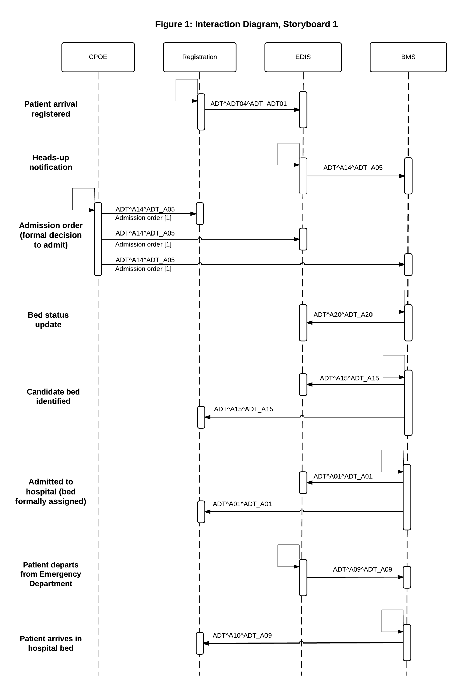

**Transactions and Interaction Diagram, Storyboard 2**

The draft interaction diagram shown in Figure 2 illustrates the transactions used in a profile that supports Storyboard 2. With the exception of the “Heads-up” notification – which could be considered optional – all the transactions listed for Storyboard 1 would pertain to Storyboard 2. Two additional transactions would be needed to define workflow timestamps:

* ORU^R30^ORU_R30 - Unsolicited Point-Of-Care observation message without existing order
* ADT^A54^ADT_A54 - Change Attending Doctor

These proposed transactions are diagramed in Figure 2.

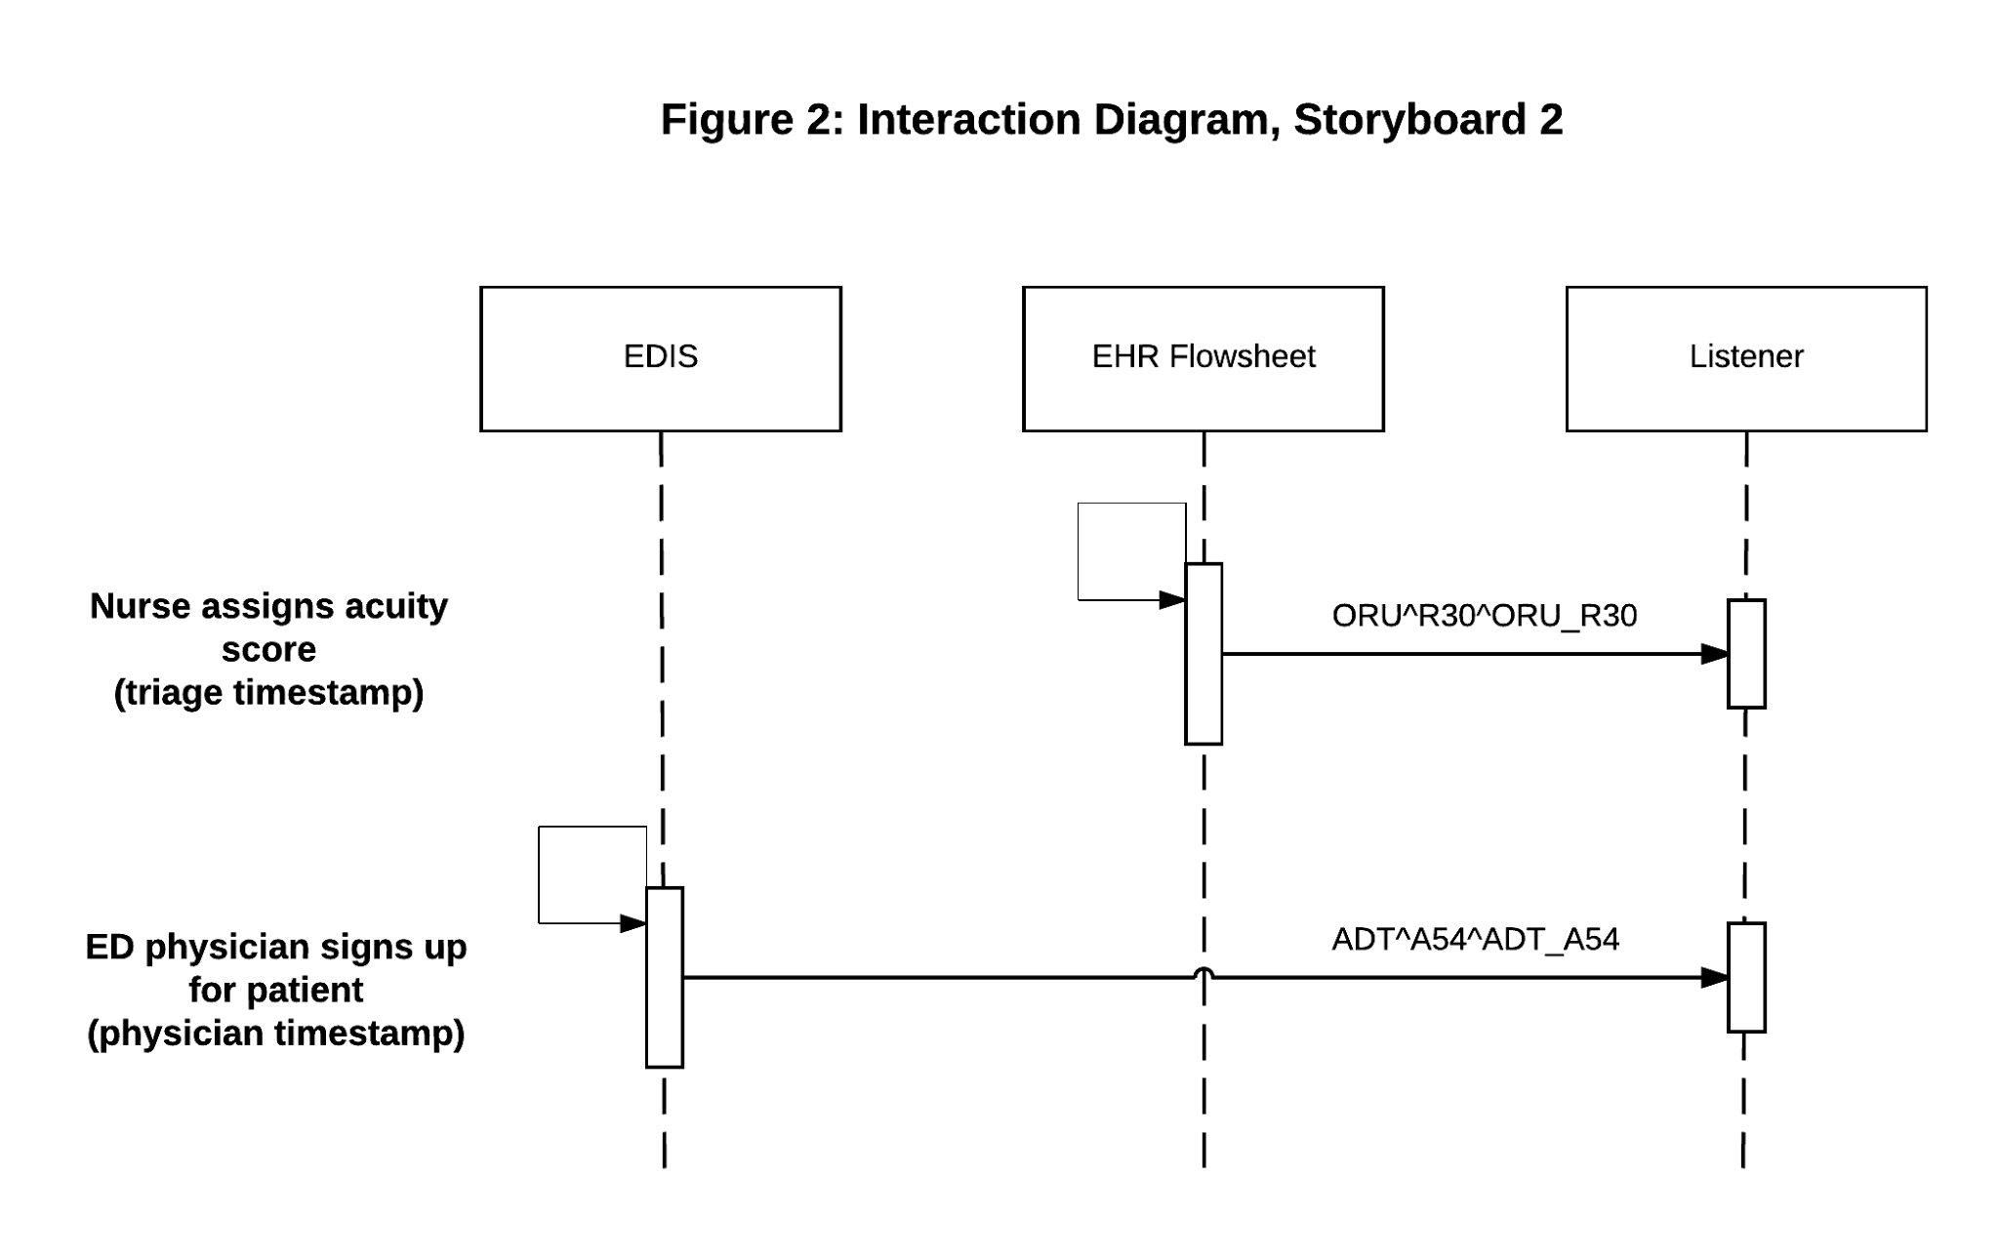

**7. Discussion**

The goal of this document is to create the foundation for a profile that describes how interoperable systems enable bed management for the use case of patients admitted from the ED. This document could serve as a jumping-off point for further exploration of how to incorporate intra-facility and inter-facility transfers as well as scheduled/planned or unscheduled/direct admissions into the bed management workflow.

We considered adding certain workflows to our document – for example, a description of the handling of communications from the ED doctor to the inpatient team and a description of the communications between the ED and inpatient nurses. In the end, however, we decided to exclude these workflows because they are site-specific and ultimately depend on the technologies available at a given institution. Some sites rely on back-and-forth phone messages, some use pagers, and some have point-to-point radio (e.g., Vocera Communication Badge4 or similar technologies). Given that the solution (and how closely it can be incorporated into an IT product) relies heavily on the constraints of the technology in place, we felt it best to move this variability outside this document. We also did not include data from a real-time location system (RTLS). This technology might relieve staff members from manually entering patient movements and could contribute to increased accuracy of time points of care; however, RTLS data is not a panacea – it will only improve capture of events that involve patient or staff movements, and only to the degree that these are accurate and appropriately interpreted.

We chose HL7v2 messages for this project. For the most part, these messages encompass the necessary data items and complexity needed for the workflows. This choice is not fixed in stone, and it is quite possible that recent developments (in FHIR, for example) will create opportunities for greater flexibility without the loss of structure necessary to achieve interoperability.

From the perspective of ED administration, the interoperability of patient flow monitoring systems (EDIS and BMS functions) garners significant benefits. When EDIS and BMS functionality is separate, ED staff are unaware of bed status, and the bed czar is unaware of future ED demand for inpatient beds. Most ED chiefs would agree that patient boarding is the single greatest impediment to improved patient experience (both in terms of satisfaction and safety of services). The main reason for this is that modern EDs are not designed for the management of inpatients over time – they are designed for the rapid identification of life-threatening disease, stabilization, and appropriate handoff to the next level of care. The workflow and practices of ED doctors and nurses is not geared for timed dispensing of medications, routine vital signs, and 24-hour flow cycles of care.

Interoperable systems between ED and inpatient admissions will break down the data silos that can often exist in healthcare environments. These silos make insight regarding cross-department flow much more costly to achieve, as various data sources must be knitted together, care must be taken to match cases across systems, and so on. Many facilities cannot easily answer questions such as “Do patients who board for prolonged periods in the ED have increased length of stay or increased morbidity or mortality in the hospital compared to their peers?”

**Prediction Modeling of ED Admissions for Bed Management**

Use of this profile would make real-time data available for prediction modeling systems. Various researchers have tried to create prediction rules to estimate the number of admissions that a given ED will generate using Bayesian analysis5 or other methods6. The hope of these models is that they can provide advanced notice to the bed czar to help manage the scarce resource of beds. These models are of varying levels of effectiveness with slight increases in accuracy as greater numbers of predictors are involved.

These predictors incorporated in these models include:

* average number of visits per day for that ED setting
* the day of the week, including whether the day is a national holiday or day(s) after a holiday
* seasonal trends of visits
* average percentage of patients admitted
* patient-specific data available at triage: age, method of arrival (walk-in, ambulance), acuity level at triage on some formal scale, chief complaint of patient coded into a standardized system, hour of arrival, initial vital signs
* nursing or physician estimate of likelihood of admission (In one study, the triage nurse predicted admissions with a sensitivity of 75.6% (95% confidence interval [CI] 71.3-79.5) and a specificity of 84.5% (95% CI 83.1-85.8) and did even better in the over 50% of cases where the triage nurse stated strong confidence in the prediction.7)
* data which becomes available during an ED visit: lab results, changes in vital signs
* historical patient data in the EHR, such as the number of admissions in the past quarter or year, percent likelihood of admission during prior ED visits, and score of medical complexity based on pre-existing conditions

A larger question remains: if a healthcare organization could predict every patient’s eventual admission perfectly at the moment of arrival in the ED, how beneficial would this information be to resource planners or hospital administrators? This depends on a few factors, the most significant of which is the percentage of all admissions of the hospital that come from the ED. In sites with high linkage between ED and inpatient census, the utility of prediction systems is higher. Another factor is the degree of flexibility and responsiveness the hospital has too high or low ED admissions. There is not a lot of lead time between ED arrival and bed request for most patients; a system has to be fairly agile, for instance, to be able to capitalize on light ED traffic by reducing inpatient staffing. Predictive modeling of admissions from the ED is a theoretically interesting problem, but the level of complexity and flexibility at which a healthcare institution needs to operate to be able to make use of this predictive data in a meaningful way remains unclear. What is clear, however, is that local data-driven modeling of patient flow is less feasible without coherent timestamp indicators. Timed messages triggered by real patient flow events are one way to generate these indicators in a standard way.

**8. References**

1. Veterans Health Administration corporate data warehouse, unpublished data.

2. Pines JM, Batt RJ, Hilton JA, Terwiesch C. The Financial Consequences of Lost Demand and Reducing Boarding in Hospital Emergency Departments. Ann Emerg Med. 2011 Oct;58(4):331–40.

3. Singer AJ, Thode HC, Jr., Viccellio P, Pines JM. The association between length of emergency department boarding and mortality. Acad Emerg Med. 2011;18(12):1324-9.

4. Vocera Communication Badge. Vocera Communications website. <http://www.vocera.com/product/vocera-communication-badge>. Accessed September 3, 2015.

5. Leegon J, Jones I, Lanaghan K, Aronsky D. Predicting Hospital Admission for Emergency Department Patients using a. AMIA Annu Symp Proc. 2005;2005:1022.

6. Peck JS, Benneyan JC, Nightingale DJ, Gaehde SA. Predicting emergency department inpatient admissions to improve same-day patient flow. Acad Emerg Med. 2012;19(9):E1045-54.

7. Kosowsky JM, Shindel S, Liu T, Hamilton C, Pancioli AM. Can emergency department triage nurses predict patients' dispositions? The American Journal of Emergency Medicine.19(1):10-4.